 **State Bank of India**

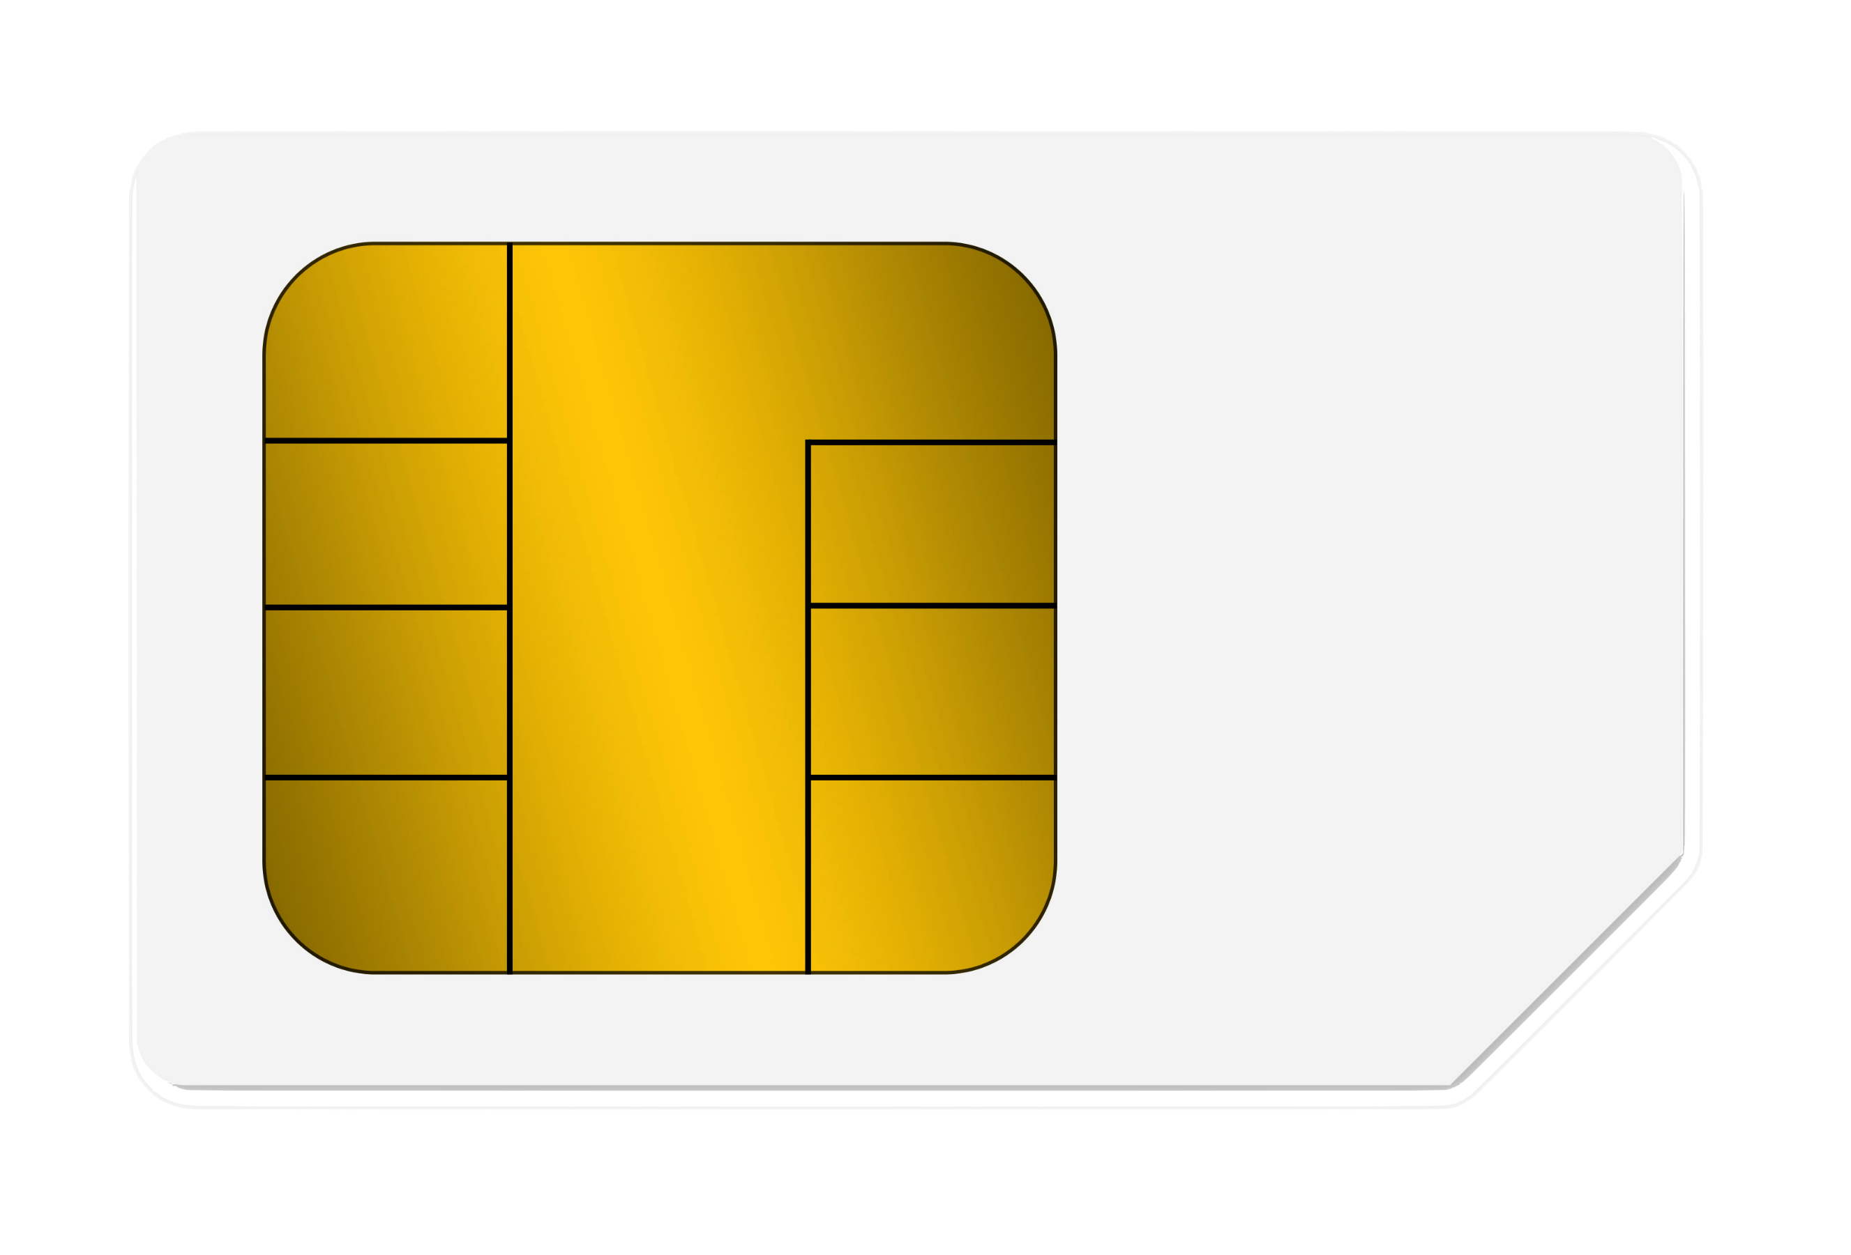

4 SBI Valid Throw

4SBI Valid Throw

VVV